A000-Eur-Greek-Hellenistic- Rooster Terracotta Figurine, 3rd to 1st Century BCE.

Case No.: 4

Hellenistic Greek  Rooster Terracotta Figurine, 3rd to 1st Century BCE.

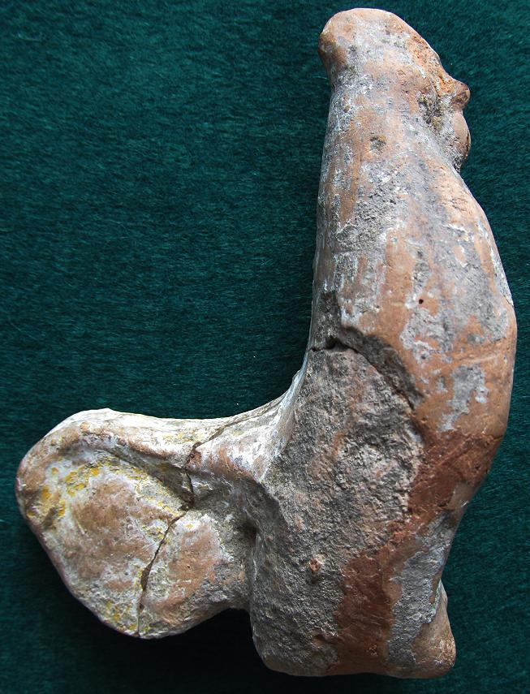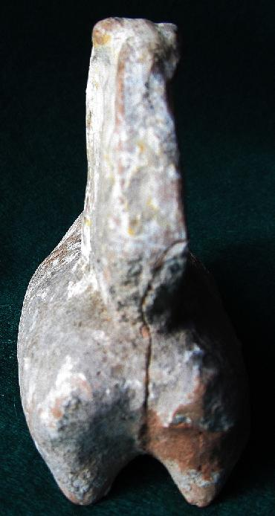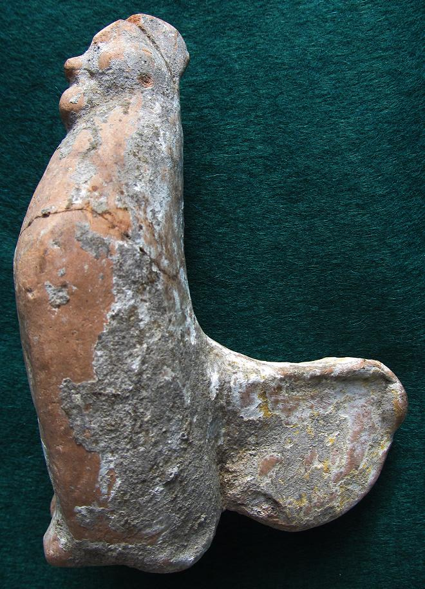

# This terracotta rooster in erect, strutting posture with prominent comb, wattles and long curving sickle tail feathers conveys all the characteristics of a domesticated red jungle-fowl (Carter 1923). On the one hand the rooster is a chthonic attribute of Persephone as represented in the sanctuary **of Demeter and Kore at Corinth.** On the other hand, the rooster is incorporated into the iconography of the Gnostic solar deity Abrasax with his rooster head in heaven and his serpent feet in hell, the destroyer of the chthonic giants (Merker 2000: 269). Thus Abrasax becomes a solar ruler like the conflated Re-Osiris, **Yahweh, Mithras, Yeshu (Jesus) and the Celtic Belenus**. This rooster may, therefore, represent both the heavenly and chthonic aspects of Abrasax.

# The provenance of this rooster is unknown but it may be from Abai where three similarly constructed specimens were excavated in 1896 by the British School at Athens: "Mouldmade body, handmade legs applied separately. Small circular vent-hole underneath. Clay: reddish yellow. Decoration: white slip. Remnants of red, yellow and black paint on comb, wattle, tail and wings" (see Fig. 3) and another cock figurine with well defined facial features and a modelled comb and bulging eyes the latter being dated to the early or mid-fifth century BCE (see Fig. 4) (Pisani 2006, no. 104, pl. 32b, no. 107, fig. 28). Abai was an important city near Hyampolis on a tributary of the Kephisos and on the main Orchomenos-Opous road from E Lokris into NE Phokis ([**Pausanias. 10.1.1**](http://www.perseus.tufts.edu/hopper/text?doc=Paus. 10.1.1&lang=original), 35.1). After two famous Phokian victories over the Thessalians shortly before 480 BCE ([**Herodotus. 8.27-28**](http://www.perseus.tufts.edu/hopper/text?doc=Hdt. 8.27&lang=original); [**Pausanias. 10.1.3-11**](http://www.perseus.tufts.edu/hopper/text?doc=Paus. 10.1.3&lang=original)), the spoils and colossal figures were dedicated to the famous oracular shrine of Apollo at Abai ([**Herodotus 1.46**](http://www.perseus.tufts.edu/hopper/text?doc=Hdt. 1.46&lang=original)). Perhaps this rooster was part of these dedicated spoils.

# 

# Fig. 3. From Pisani 2006, 104 (T34), pl. 32b. Fig. 4. From Pisani 2006 no. 107, fig. 28. Cm. scale at right

# References:

# Carter, H. 1923. "An ostracon depicting a red jungle-fowl the earliest known drawing of the domestic cock." *Journal of Egyptian Archaeology* 9: 1-4.

# Merker, G. 2000. *The sanctuary of Demeter and Koré: terracotta figurines of the Classical, Hellenistic, and Roman periods* (Princeton: American School of Classical Studies at Athens, 2000).

Pisani, Marcella. 2006. The Collection of Terracotta Figurines in the British School at Athens, *The Annual of the British School at Athens,* 101: 269-368.